# CS 255 System Design Document Template

This template lays out all the different sections that you need to complete for Project Two. Each section has guidance to prompt your thinking. You will need to continually reference the interview transcript as you work to make sure that you are addressing your client’s needs. There is no required length for the final document. Instead the goal is to complete each section based on what your client’s needs are. Remove this note when you are finished, and replace all bracketed text with the relevant information.

## UML Diagrams

### UML Use Case Diagram

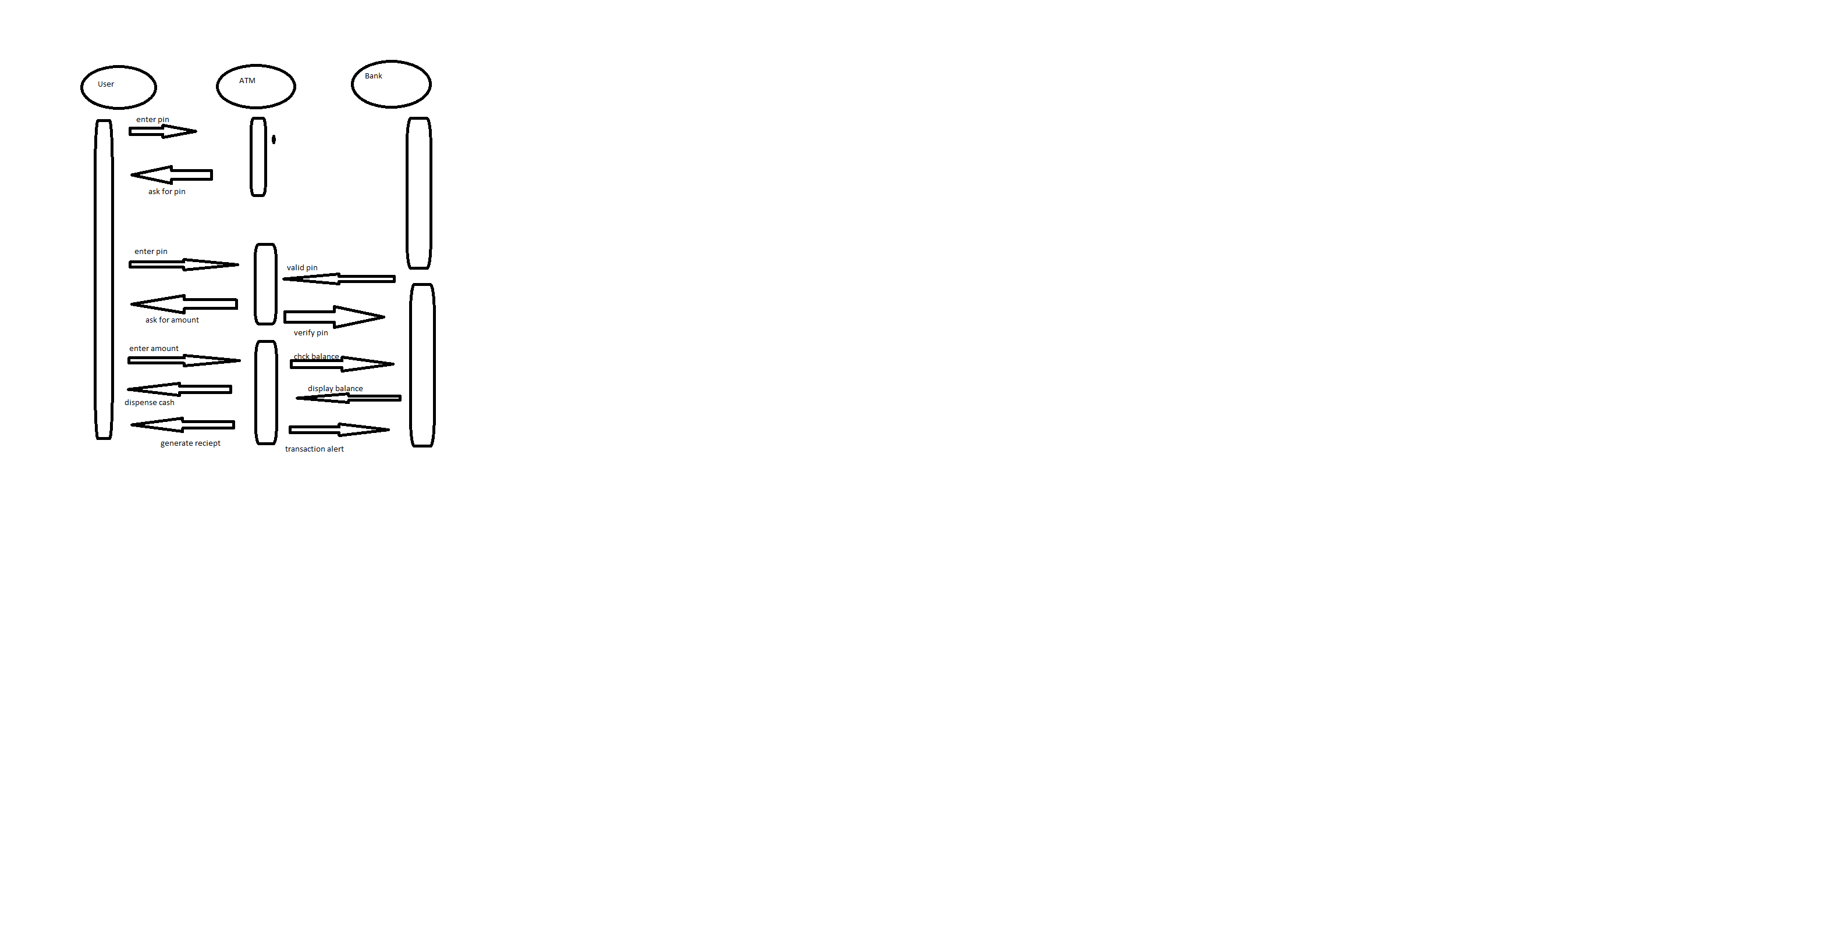

### UML Activity Diagrams

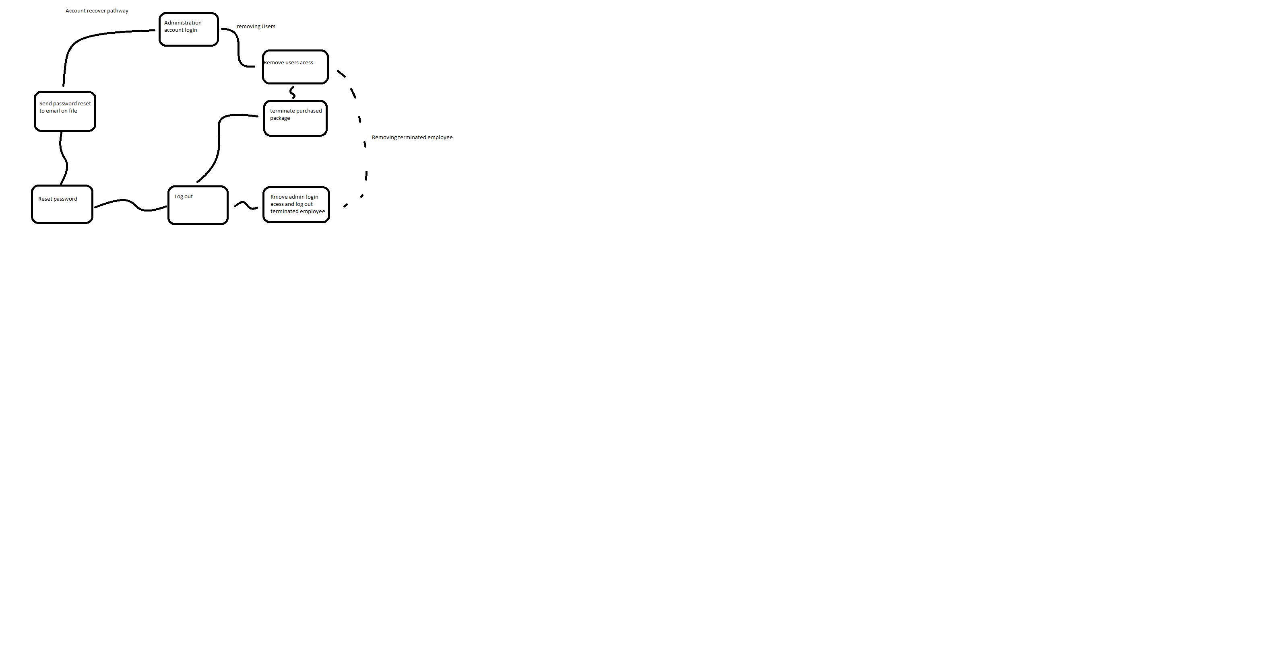

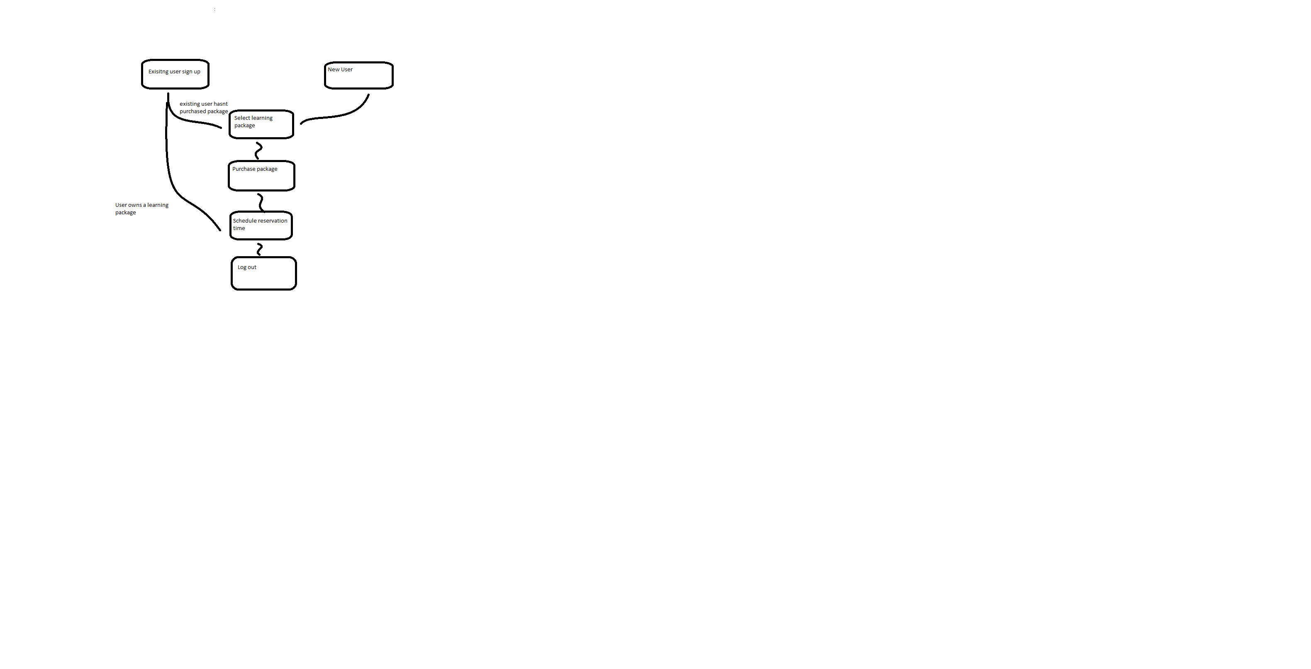

### UML Sequence Diagram

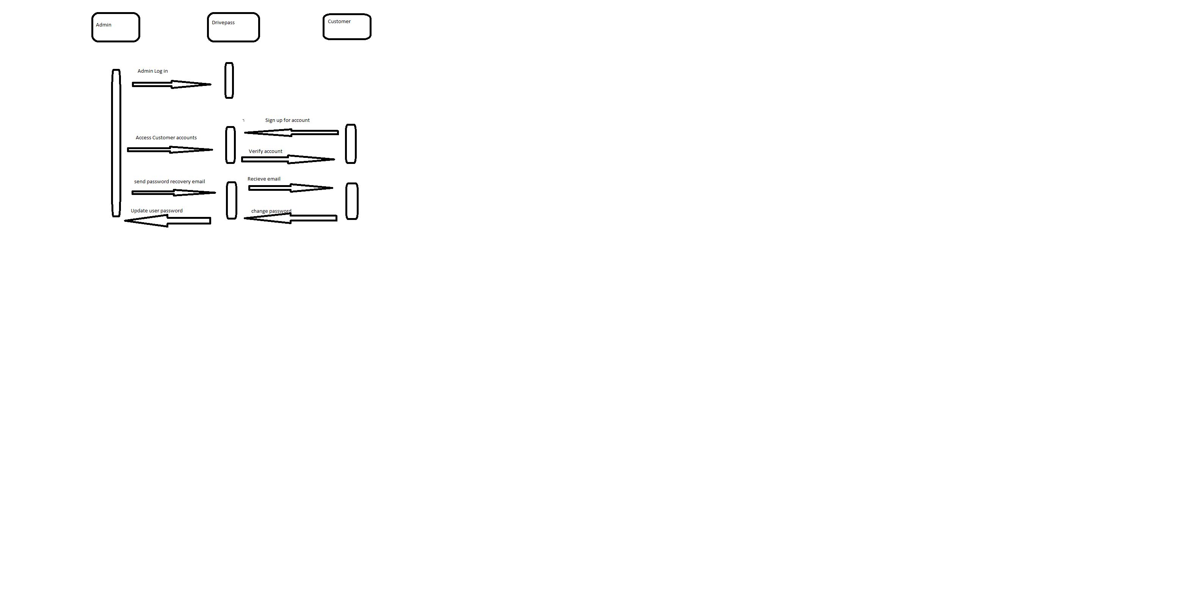

### UML Class Diagram

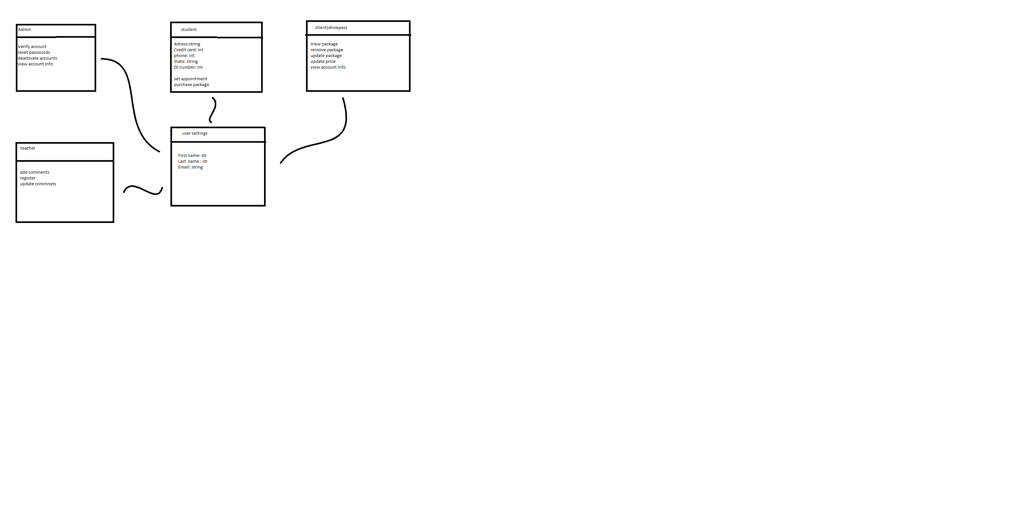

## Technical Requirements

hardware and software requirements for both the host and client in a network setup:

**Hardware Requirements for Host**

- At least one physical server

- Network cables to connect the server and associated equipment

- A monitor, keyboard, and mouse for user interaction

- Adequate power sources to ensure continuous operation

- Connectivity to an internet provider

**Hardware Requirements for Client**

- A desktop or laptop computer

- A Wi-Fi router or an Ethernet cable for network connectivity

- Reliable power sources to ensure uninterrupted operation

- Access to an internet service provider

**Software Requirements for Client**

- Web browser application (Firefox, Chrome, etc.)

- Operating system (such as Mac, Linux, Windows, etc.)

- Security software to safeguard sensitive information

**Tools Required for Development**

- Computers equipped with programming software (Visual Studio, Eclipse, etc.)

- A reliable internet connection for uploading to the server

- Network administration tools for monitoring and detecting suspicious network traffic

**Infrastructure Required**

- A server location or cloud service provider for hosting and managing server resources